PIZZA SALES SQL QUERIES
A. KPI’s

1. Total Revenue

SELECT SUM(total_price) AS Total_Revenue FROM pizza_sales
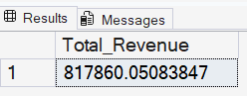

2.Average Order Value

SELECT (SUM(total_price) / COUNT(DISTINCT order_id)) AS Avg_order_Value FROM pizza_sales
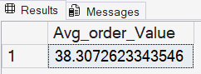

3. Total Pizza Sold

SELECT SUM (quantity) AS Total_pizza_sold from pizza_sales
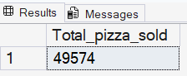

4. Total Order

SELECT COUNT (DISTINCT order_id) AS Total_Orders FROM pizza_sales
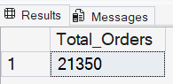

5. Average Pizzas Per Order

SELECT CAST(CAST(SUM(quantity) AS DECIMAL(10,2)) /
CAST(COUNT(DISTINCT order_id) AS DECIMAL(10,2)) AS DECIMAL(10,2))
AS Avg_Pizzas_per_order
FROM pizza_sales

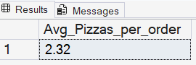

B. Daily Trend for Total Orders
SELECT DATENAME(DW, order_date) AS order_day, COUNT(DISTINCT order_id) AS total_orders
FROM pizza_sales
GROUP BY DATENAME(DW, order_date)
Output:
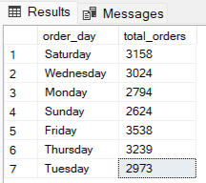

C. Monthly Trend for Orders

select DATENAME(MONTH, order_date) as Month_Name, COUNT(DISTINCT order_id) as Total_Orders
from pizza_sales
GROUP BY DATENAME(MONTH, order_date)Output
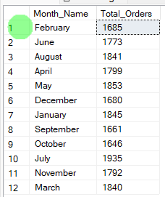
D. % of Sales by Pizza Category

SELECT pizza_category, CAST(SUM(total_price) AS DECIMAL(10,2)) as total_revenue,
CAST(SUM(total_price) * 100 / (SELECT SUM(total_price) from pizza_sales) AS DECIMAL(10,2)) AS PCT
FROM pizza_sales
GROUP BY pizza_category
Output
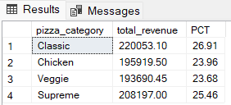

E. % of Sales by Pizza Size

SELECT pizza_size, CAST(SUM(total_price) AS DECIMAL(10,2)) as total_revenue,
CAST(SUM(total_price) * 100 / (SELECT SUM(total_price) from pizza_sales) AS DECIMAL(10,2)) AS PCT
FROM pizza_sales
GROUP BY pizza_size
ORDER BY pizza_size
Output
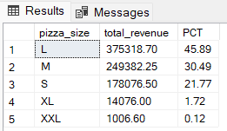

F. Total Pizzas Sold by Pizza Category

SELECT pizza_category, SUM(quantity) as Total_Quantity_Sold
FROM pizza_sales
WHERE MONTH(order_date) = 2
GROUP BY pizza_category
ORDER BY Total_Quantity_Sold DESC
Output
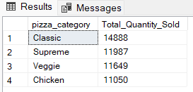

G. Top 5 Pizzas by Revenue
SELECT Top 5 pizza_name, SUM(total_price) AS Total_Revenue
FROM pizza_sales
GROUP BY pizza_name
ORDER BY Total_Revenue DESC
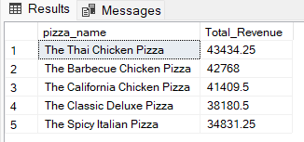

H. Bottom 5 Pizzas by Revenue
SELECT Top 5 pizza_name, SUM(total_price) AS Total_Revenue
FROM pizza_sales
GROUP BY pizza_name
ORDER BY Total_Revenue ASC
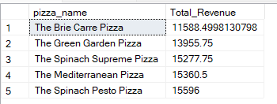

I. Top 5 Pizzas by Quantity

SELECT Top 5 pizza_name, SUM(quantity) AS Total_Pizza_Sold
FROM pizza_sales
GROUP BY pizza_name
ORDER BY Total_Pizza_Sold DESC
Output
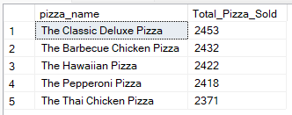

J. Bottom 5 Pizzas by Quantity

SELECT TOP 5 pizza_name, SUM(quantity) AS Total_Pizza_Sold
FROM pizza_sales
GROUP BY pizza_name
ORDER BY Total_Pizza_Sold ASC
Output
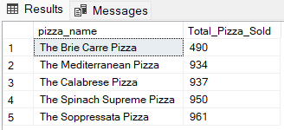

K. Top 5 Pizzas by Total Orders
SELECT Top 5 pizza_name, COUNT(DISTINCT order_id) AS Total_Orders
FROM pizza_sales
GROUP BY pizza_name
ORDER BY Total_Orders DESC
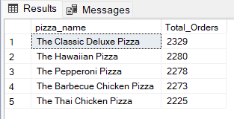

L. Borrom 5 Pizzas by Total Orders

SELECT Top 5 pizza_name, COUNT(DISTINCT order_id) AS Total_Orders
FROM pizza_sales
GROUP BY pizza_name
ORDER BY Total_Orders ASC
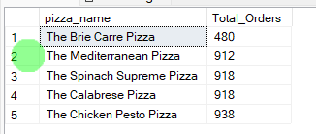

NOTE
If you want to apply the pizza_category or pizza_size filters to the above queries you can use WHERE clause. Follow some of below examples
SELECT Top 5 pizza_name, COUNT(DISTINCT order_id) AS Total_Orders
FROM pizza_sales
WHERE pizza_category = 'Classic'
GROUP BY pizza_name
ORDER BY Total_Orders ASC

